PROJECT DEVELOPMENT PHASE 1
Requirement Gathering
Script-Controlled ACL – Restrict Record Access Based on Field Value
Project Details | Values
Date | 30 September 2026
Team ID | SWTID-2026-8983
Project Name | Script-Controlled ACL – Restrict Record Access Based on Field Value
Phase | Phase 1 – Requirement Gathering
Maximum Marks | 5 Marks

Team Role | Team Member
Team Leader | NITHYA SREE S
Team Member | RAMASRI D
Team Member | PRATHISHA S
Team Member | MEGALA M
Team Member | MANJARI T

1. Objective
Understand the business need and identify which records must be visible to which users based on a field value.

2. Phase Workflow
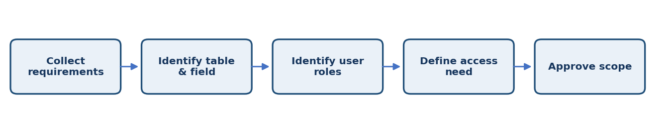

3. Activities / Scope
- Meet the project owner and confirm the access-control requirement.
- Identify the target ServiceNow table and record types.
- Identify the field whose value controls access.
- List user types, groups, roles, and record owners involved.
- Record assumptions, limitations, and acceptance criteria.

4. Sprint Backlog & Estimation
Sprint | Story ID | Requirement | User Story / Task | Story Points | Priority | Team Members
Sprint 1 | US-101 | Gather requirements | Document table, field, access operation, and business need. | 2 | Medium | Project Team
Sprint 1 | US-102 | Identify user groups | List users and roles that need or must not have access. | 2 | Medium | Project Team
Sprint 1 | US-103 | Define acceptance criteria | Write measurable allow/deny outcomes. | 2 | Medium | Project Team

Total Estimated Story Points: 6

5. Testing / Review Template
Test Case ID | Scenario / Steps | Expected Result | Actual Result | Status
TC-01 | Review requirements with the project owner and confirm that each user group and field value has an expected access outcome. | Expected behavior matches approved requirement. | ________________ | Pass / Fail
TC-02 | Record observations, issues, and evidence for this phase. | No unresolved blocker before phase sign-off. | ________________ | Pass / Fail
TC-03 | Review phase deliverables with the responsible team member. | Deliverables reviewed and approved. | ________________ | Pass / Fail

6. Deliverables
- Requirement document
- Stakeholder and role list
- Acceptance criteria

7. Team Review & Sign-off
Review Item | Details
Prepared by | Megala M / Project Team
Reviewed by | ____________________________
Approval / Date | ____________________________
Remarks | ________________________________________________

